IELTS ACADEMIC LISTENING TEST 2

Time: Approximately 30 minutes (plus 10 minutes transfer time) Total questions: 40 INSTRUCTIONS TO CANDIDATES - Answer all questions. - You will hear each recording ONCE only. At the end of the test, you will have 10 minutes to transfer your answers to an answer sheet.

SECTION 1 Questions 1-10

You will hear a conversation between a student and a librarian about registering for a library card.

Questions 1-5

Complete the form below. Write NO MORE THAN TWO WORDS AND/OR A NUMBER for each answer.

LIBRARY REGISTRATION FORM

Full Name: Sarah 1 __________________

Date of Birth: 2 __________________ 1998

Student ID: 3 __________________

Contact Number: 4 __________________

Email: 5 __________________ @university.edu

Questions 6-10

Choose the correct letter, A, B or C.

6 How many books can students borrow at one time?

A 5 books

B 10 books

C 15 books

7 How long is the standard loan period?

A 2 weeks

B 3 weeks

C 4 weeks

8 What happens if a book is overdue?

A A fine of 50p per day

B A fine of £1 per day

C Borrowing privileges are suspended

9 Which resource is NOT available online?

A Journal articles

B Video tutorials

C Physical archives

10 When is the library open until 10 PM?

A Monday to Friday

B Monday to Thursday

C Every day

SECTION 2 Questions 11-20

You will hear a tour guide describing the National Science Museum.

Questions 11-15

Choose the correct letter, A, B or C.

11 The museum was originally opened in

A 1857

B 1887

C 1927

12 The Space Exploration gallery features

A a real moon rock

B a flight simulator

C both of the above

13 Interactive exhibits are particularly designed for

A university students

B children under 12 C all ages

14 The museum café is located on the

A ground floor

B second floor

C third floor

15 Special exhibitions change every

A three months

B six months

C twelve months

Questions 16-20

Label the museum floor plan. Write the correct letter, A-H, next to Questions 16-20.

16 Energy and Power Gallery __________

17 Medical Innovations Gallery __________

18 Gift Shop __________

19 Information Desk __________

20 Temporary Exhibition Space __________

SECTION 3 Questions 21-30

You will hear two students, Emma and Tom, discussing their psychology research project.

Questions 21-25

What decision do the speakers make about each aspect of their research? Write the correct letter, A-F, next to Questions 21-25.

Decisions:

A Already decided

B Needs further research

C Will be randomized

D Depends on budget

E Must be approved by ethics committee

F Will use self-reporting

21 Research methodology __________

22 Number of participants __________

23 Order of memory tests __________

24 Sleep measurement method __________

25 Participant compensation __________

Questions 26-30

Choose the correct letter, A, B or C. 26 How many experimental groups will the study have? A Two groups

B Three groups

C Four groups

27 Tom suggests limiting sleep deprivation to

A one night

B two nights

C three nights

28 The memory tests should be conducted

A in the evening

B at different times for different participants

C in the morning at the same time

29 What statistical test do they plan to use?

A T-test

B ANOVA

C Chi-square

30 They plan to meet again to work on the ethics application

A this weekend

B on Monday

C on Tuesday

SECTION 4 Questions 31-40

You will hear a lecture about water conservation strategies in urban areas.

Questions 31-34

Complete the sentences below. Write NO MORE THAN TWO WORDS for each answer.

31 Urban areas consume approximately __________________ of the world's freshwater supply.

32 Rainwater harvesting systems can reduce household water usage by up to __________________.

33 Grey water refers to water from sinks, showers, and __________________. 34 Smart irrigation systems use __________________ to determine when watering is needed.

Questions 35-40

Complete the table below. Write NO MORE THAN TWO WORDS AND/OR A NUMBER for each answer.

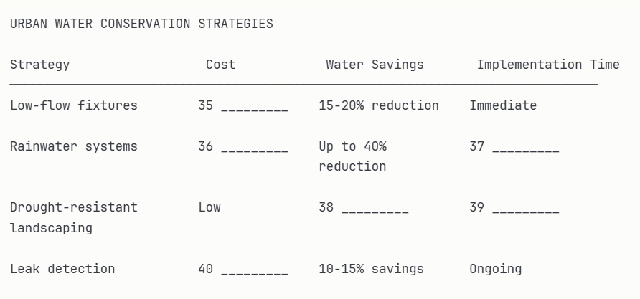

ANSWER KEY - ACADEMIC LISTENING TEST 2

Section 1:

1. Henderson

2. 15th March / 15 March / March 15

3. LB47293

4. 07892 445 621

5. s.henderson

6. B

7. B

8. A

9. C

10. B

Section 2:

11. B (1887)

12. C (both)

13. C (all ages)

14. B (second floor)

15. B (six months)

16. B

17. E

18. G

19. A

20. F

Section 3:

21. A (Already decided - mixed methods)

22. A (Already decided - 30 participants)

23. C (Will be randomized)

24. F (Will use self-reporting - sleep diaries)

25. A (Already decided - £20)

26. B (Three groups)

27. A (one night)

28. C (morning at same time)

29. B (ANOVA)

30. C (Tuesday)

Section 4:

31. three-quarters / 75%

32. 40% / forty percent

33. washing machines

34. sensors / soil moisture

35. £50-150 / Low

36. £2,000-5,000 / High

37. two weeks / 2 weeks

38. 50-70% / 50-70 percent

39. 2-3 months / two to three months

40. Varies